**Practical – 5**

**Working with Multimedia**

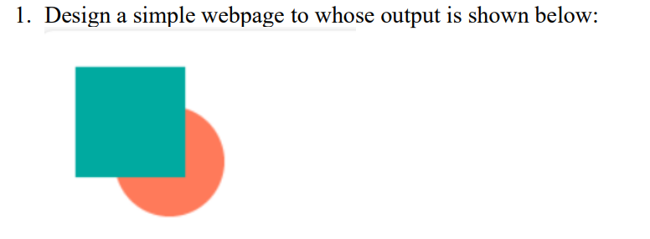

**HTML Code**

<html>

    <head>

        <title>

           HTML Practical

        </title>

    </head>

    <body>

        <canvas id="myCanvas" height="500px" width="500px" style="border: 1px solid black;"></canvas>

        <script>

*var* canvas = document.getElementById("myCanvas");

*var* c = canvas.getContext("2d");

            c.beginPath();

            c.arc(150,150,90,0,2 * Math.PI);

            c.fillStyle = "orange";

            c.fill();

            c.stroke();

            c.beginPath();

            c.rect(35,30,150,150);

            c.fillStyle = "lightgreen";

            c.fill();

            c.stroke();

        </script>

    </body>

</html>

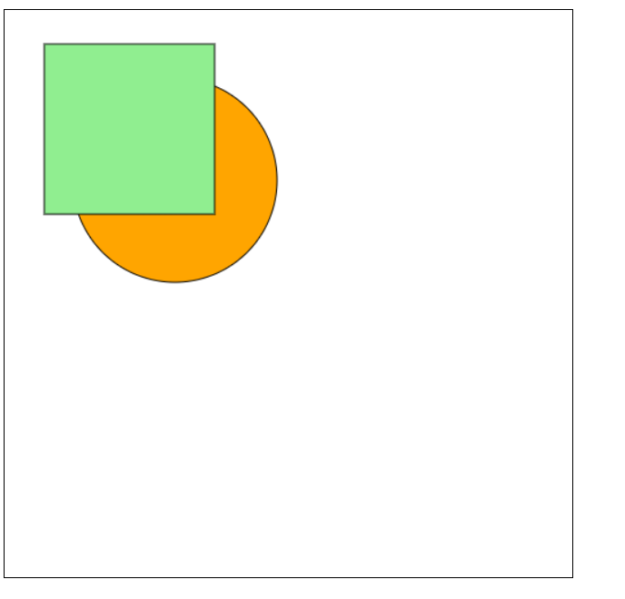**Output**

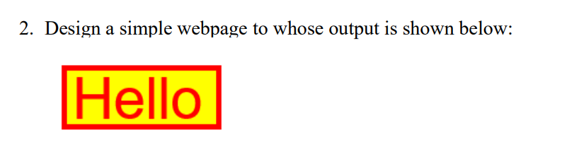**Practical – 5**

**HTML Code**

<html>

<head>

<title>

HTML Practical

</title>

</head>

<body>

<canvas id="myCanvas" height="500px" width="500px" style="border: 1px solid black;"></canvas>

<script>

var canvas = document.getElementById("myCanvas");

var c = canvas.getContext("2d");

c.beginPath();

c.rect(20,20,200,80);

c.fillStyle = "yellow";

c.fill();

c.strokeStyle = "red";

c.stroke();

c.font = "40px Arial";

c.fillStyle = "red";

c.fillText("Hello",70,70);

</script>

</body>

</html>

**Output**

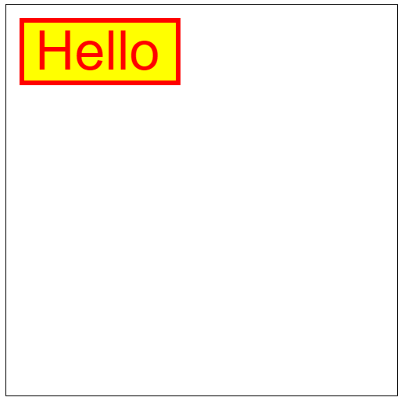

**Practical – 5**

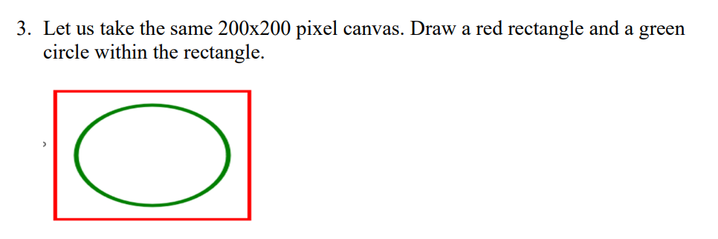

**HTML Code**

<html>

<head>

<title>

HTML Practical

</title>

</head>

<body>

<canvas id="myCanvas" height="500px" width="500px" style="border: 1px solid black;"></canvas>

<script>

var canvas = document.getElementById("myCanvas");

var c = canvas.getContext("2d");

c.beginPath();

c.rect(100,100,250,180);

c.strokeStyle = "red";

c.lineWidth = 5;

c.stroke();

c.scale(1.5,1);

c.beginPath();

c.arc(150,190,70,0,Math.PI * 2,false);

c.strokeStyle = "green";

c.stroke();

</script>

</body>

</html>

**Output**

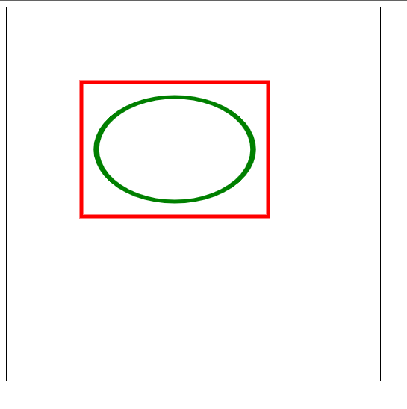

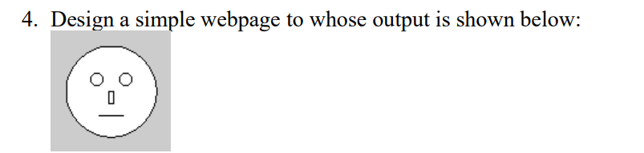**Practical – 5**

**HTML Code**

<!DOCTYPE html>

<html>

<head>

<title>Face</title>

</head>

<body>

<canvas width="200px" height="200px" id="four" style="background-color: grey;"></canvas>

<script>

const a = document.getElementById("four");

const ctx = a.getContext("2d");

ctx.beginPath();

ctx.arc(100,100,70,0,360);

ctx.strokeStyle = "black";

ctx.stroke();

ctx.fillStyle = "white";

ctx.fill();

ctx.closePath();

ctx.beginPath();

ctx.arc(80,80,10,0,2*Math.PI);

ctx.strokeStyle = "black";

ctx.stroke();

ctx.closePath();

ctx.beginPath();

ctx.arc(120,80,10,0,2*Math.PI);

ctx.strokeStyle = "black";

ctx.stroke();

ctx.closePath();

ctx.strokeStyle = "black";

ctx.strokeRect(95,100,10,20);

ctx.beginPath();

ctx.moveTo(80,135);

ctx.lineTo(120,135);

ctx.stroke();

ctx.closePath();

</script>

</body>

</html>

**Output**

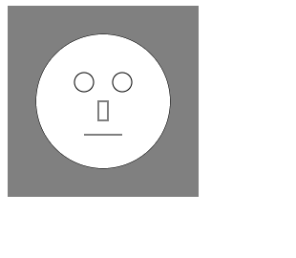

**Practical – 5**

5 . Display a simple webpage to whose output is shown below:

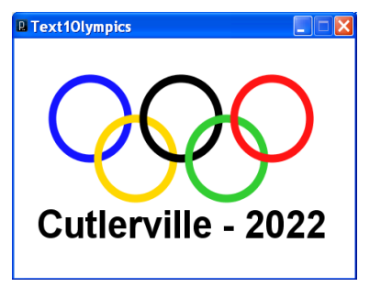

**HTML Code**

<html>

<head>

<title>HTML Practical</title>

</head>

<body>

<canvas

id="myCanvas"

height="500px"

width="500px"

style="border: 1px"

></canvas>

<script>

var canvas = document.getElementById("myCanvas");

var c = canvas.getContext("2d");

c.beginPath();

c.rect(90, 100, 250, 180);

c.lineWidth=5;

c.stroke();

c.beginPath();

c.arc(150, 150, 30, 0, Math.PI * 2);

c.strokeStyle = "blue";

c.stroke();

c.beginPath();

c.arc(179, 179, 30, 0, Math.PI * 2);

c.strokeStyle = "yellow";

c.stroke();

c.beginPath();

c.arc(215, 150, 30, 0, Math.PI * 2);

c.strokeStyle = "black";

c.stroke();

c.beginPath();

c.arc(249, 180, 30, 0, Math.PI * 2);

c.strokeStyle = "green";

c.stroke();

c.beginPath();

c.arc(280, 150, 30, 0, Math.PI * 2);

c.strokeStyle = "red";

c.stroke();

c.font = "30px Arial bold";

c.fillText("Culterville - 2022", 110, 250);

</script>

</body>

</html>

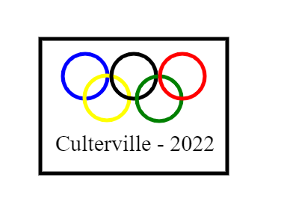**Output**

**Practical – 5**

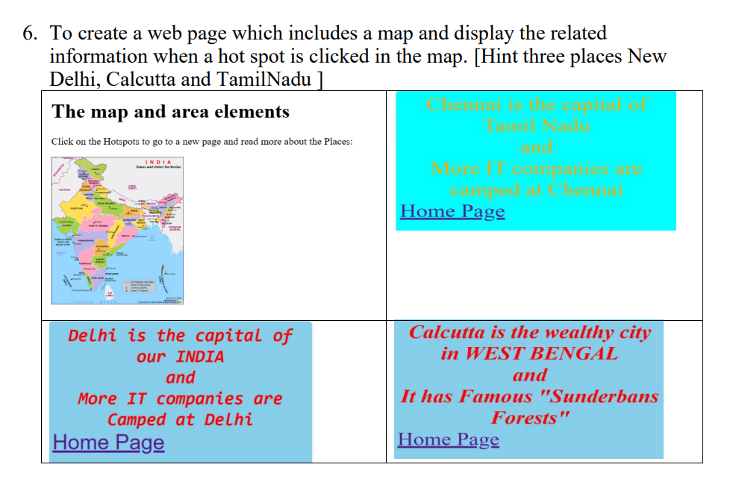

**HTML Code**

<!DOCTYPE html>

<html lang="en">

<head>

<meta charset="UTF-8">

<meta name="viewport" content="width=device-width, initial-scale=1.0">

<title>image map</title>

</head>

<body>

<img src="india.jpg" alt="india" usemap="#india">

<map name="india">

<area shape="rect" coords="245,260,264,280" href="delhi.html" alt="delhi">

<area shape="circle" coords="541,424,50" href="calcutta.html" alt="calcutta">

<area shape="poly" coords="225,765,338,713,254,871,304,828" href="chennai.html" alt="chennai">

</map>

</body>

</html>

**HTML Code (Calcutta)**

<html>

<head>

<title>Calcutta</title>

</head>

<body bgcolor="lightblue">

<i><h1 style="color:red">Calcutta is the wealthy city in WEST BENGAL</h1>

<p style="color:red">It has famous "Sunderbans Forests"</p></i>

<a href="p6.html">Home Page</a>

</body>

</html>

**HTML Code (Chennai)**

<html>

<head>

<title>Chennai</title>

</head>

<body bgcolor="cyan">

<i><h1 style="color:rgb(158, 158, 9)">chennai is the captal of Tamil Nadu</h1>

<p style="color:rgb(158, 158, 9)">More IT companies are camped at Channai.</p></i>

<a href="p6.html">Home Page</a>

</body>

</html>

**HTML Code (Delhi)**

<html>

<head>

<title>delhi</title>

</head>

<body bgcolor="lightblue">

<i><h1 style="color:red">Delhi is the capital of our INDIA</h1>

<p style="color:red">More IT companies are camped at Delhi</p></i>

<a href="p6.html">Home Page</a>

</body>

</html>

**Output**

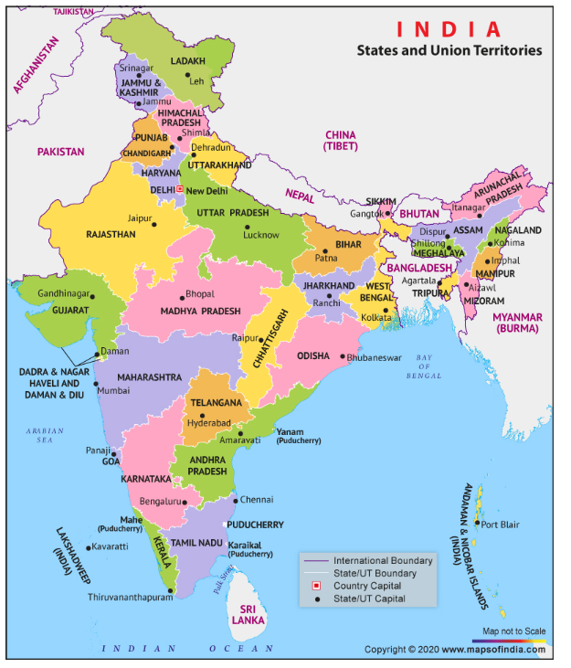

**Practical – 5**

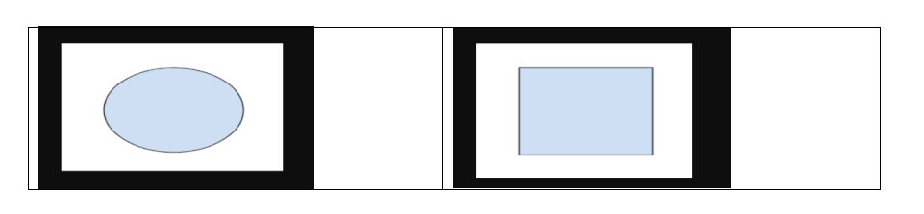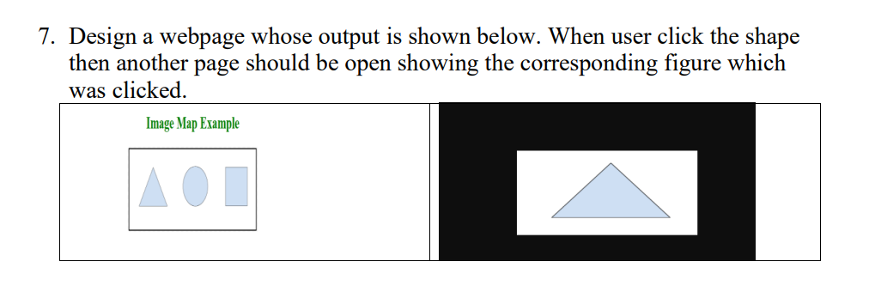

**HTML Code**

<!DOCTYPE html>

<html lang="en">

<head>

<meta charset="UTF-8">

<meta name="viewport" content="width=device-width, initial-scale=1.0">

<title>image map</title>

</head>

<body>

<h1 style="color:green">Image Map Example</h1>

<img src="area11.png" alt="area" usemap="#area">

<map name="area">

<area shape="rect" coords="658,83,807,242" href="area4.png" alt="delhi">

<area shape="circle" coords="454,158,80" href="area3.png" alt="calcutta">

<area shape="poly" coords="169,87,79,242,267,242" href="area2.png" alt="chennai">

</map>

</body>

</html>

**Output**

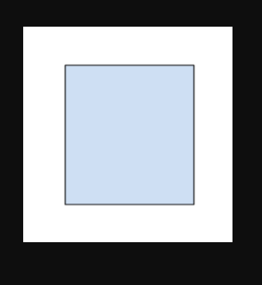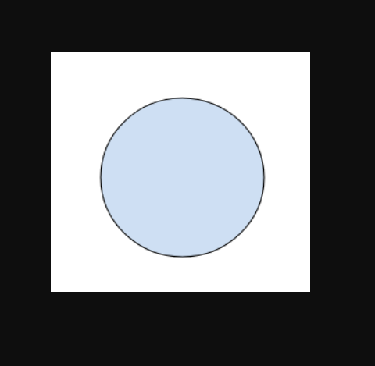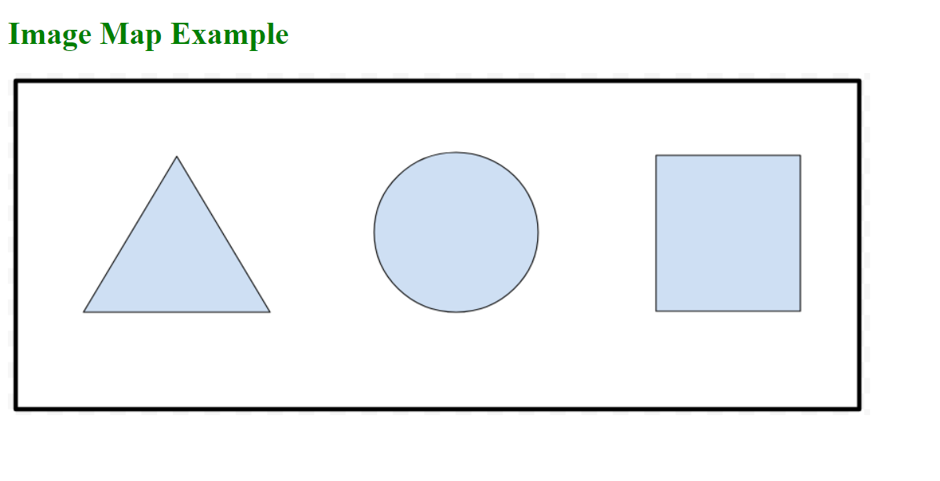

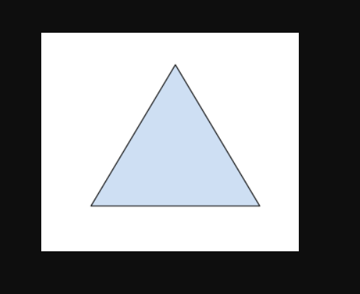

**Practical – 5**

8. Design a web page has two logical section – the first one only uses the figure markup element and the second uses both figure as well as figcaption.

**HTML Code**

<html>

<head>

<title>HTML Practical</title>

</head>

<body>

<h1>Figure and Figcaption in HTML</h1>

<div>

<figure>

<img src="india.jpg" height="300px" width="300px" />

</figure>

</div>

<div>

<figure>

<img src="india.jpg" height="300px" width="300px" />

<figcaption>Indian Map</figcaption>

</figure>

</div>

</body>

</html>

**Output**

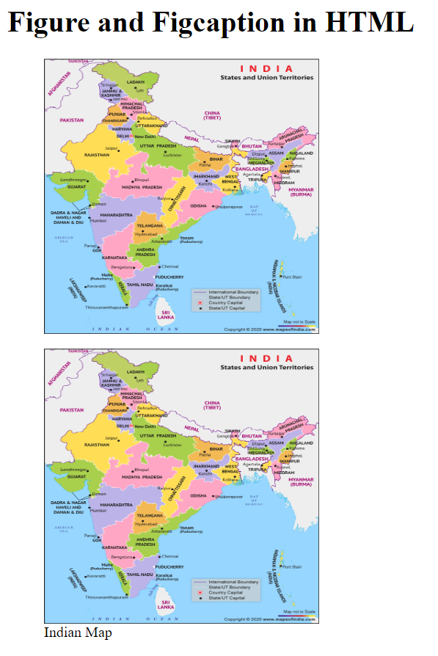

**Practical – 5**

9. Design a webpage to implement audio and video.

**HTML Code**

<html>

<head>

<title>HTML Practical</title>

</head>

<body>

<h1>Video Element</h1>

<video controls>

<source src="video.mp4" type="video/mp4" />

</video>

<h1>Audio Element</h1>

<audio controls>

<source src="audio.mp3" type="audio/mp3" />

</audio>

</body>

</html>

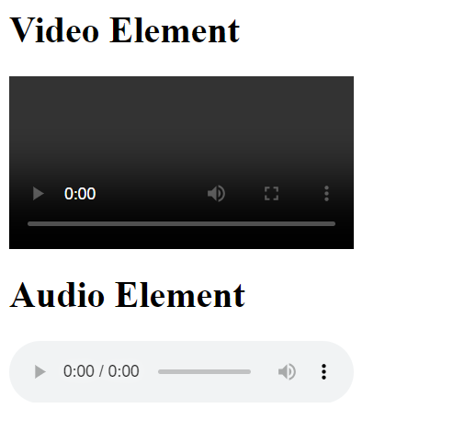**Output**